# Problem 01. SoftUni Administration

Exam problems for the [“JavaScript Advanced” course @ SoftUni](https://softuni.bg/courses/javascript-advanced). Submit your solutions in the SoftUni Judge system at <https://judge.softuni.bg/Contests/Compete/Index/2590#0>

### Use the given skeleton to solve this problem.

**Note: USE THE GOOGLE CHROME BROWSER!**

### Note: You have NO permission to change directly the given HTML *(index.html file)*.

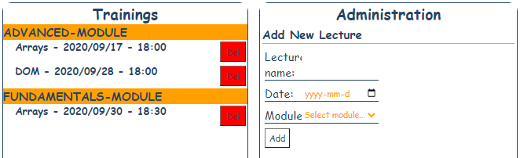

### Your Task

**Write the missing JavaScript code** to make the **SoftUni Administration Functionality** works as follows:

The **Module field** is a dropdown menu.

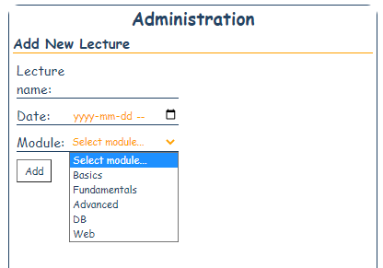

When the **Add** button is **clicked**, first you need to **validate the inputs**.

If any of the input fields is **invalid (empty or default value)**, the function **doesn’t** make anything.

Be careful with the **validation of the Module dropdown** (it's default value is **NOT** an empty string).

**After validating** the input fields, you need to **add** the new **lecture** in the **Trainings** section.

The HTML structure after adding new lecture looks like this:

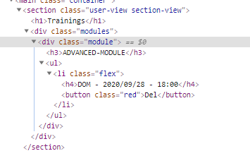

The added lecture should have **button** with text "**Del**". **The date** and the **lecture name** must be **formatted** as shown on the screenshots.

Duplicated names of the lectures are allowed.

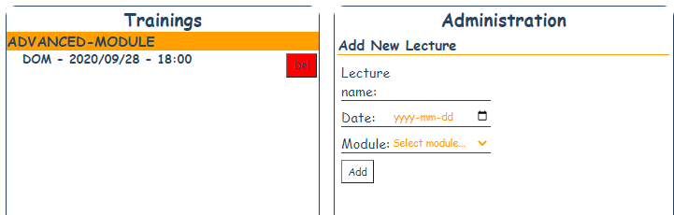

### If there is another Lecture with the same Module:

The lectures should be **sorted by DATE**! The date is separated with **slashes** (/) and the **separator** between the **date** and **time** is a **minus sign.**

**Hint: The format of the date allows alphabetical sort.**

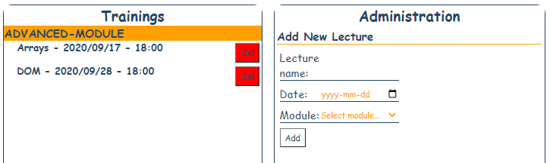

### Deleting Lecture/Module:

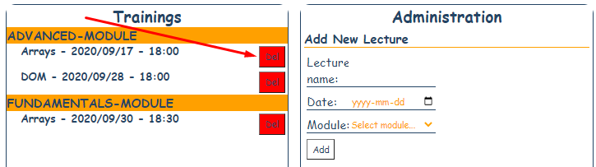

When the “**Delete**” button is clicked, the **Lecture (whole list element)** should be **removed** from the HTML.

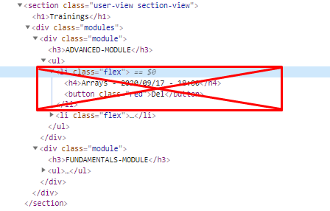

If there are **NO** Lectures left in the module (after delete) the whole **module** should be **also deleted**.

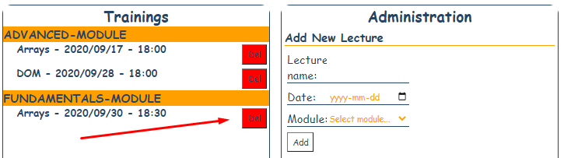

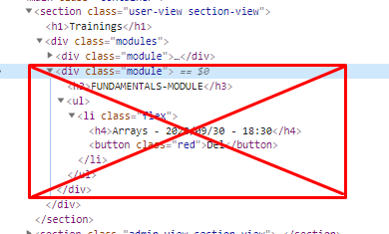

**GOOD LUCK!**